Lab No | 11,12
Name | Noor Fatima
Reg No | 23_NTU_CS_1083
Semester | BSCS(6thA)
Subject | Web Development
Submitted to | Sir Abdul Basit
Submission Date | 28_04_2026


Computer Science
National Textile University Faisalabad

Lab NO 11|12
Lab 11:
Question. No.1
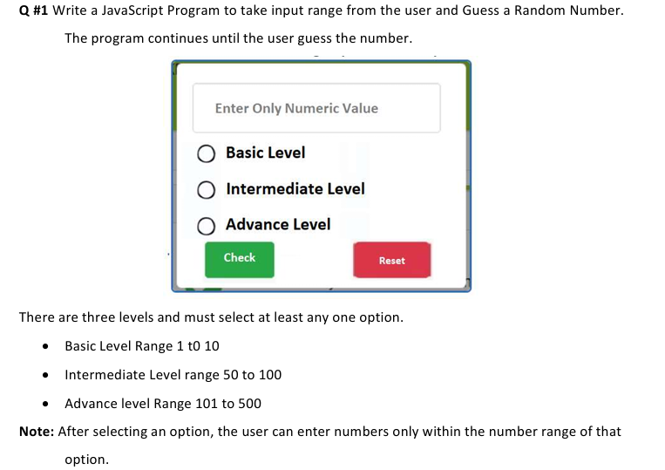
Code:
<!DOCTYPE html>
<html lang="en">
<head>
<meta charset="UTF-8" />
<meta name="viewport" content="width=device-width, initial-scale=1.0"/>
<title>Guess the Number</title>
<script src="https://cdn.tailwindcss.com"></script>
</head>
<body class="min-h-screen bg-gray-100 flex items-center justify-center p-4">

<div class="bg-white border border-gray-300 rounded-lg shadow-lg p-6 max-w-md ">
<input type="number" id="guess-input" placeholder="Enter only Numeric Value" class="flex-1 border border-gray-300 rounded px-3 py-2 focus:outline-none focus:ring-2 focus:ring-green-400"/>
<div class="mb-4">
<div class="flex flex-col space-y-2">
<label class="flex items-center space-x-3 cursor-pointer">
<input type="radio" name="level" value="basic" class="accent-green-500"/>
<span class="font-medium">Basic Level</span>
</label>
<label class="flex items-center space-x-3 cursor-pointer">
<input type="radio" name="level" value="inter" class="accent-green-500"/>
<span class="font-medium">Intermediate Level</span>
</label>
<label class="flex items-center space-x-3 cursor-pointer">
<input type="radio" name="level" value="adv" class="accent-green-500"/>
<span class="font-medium">Advance Level</span>
</label>
</div>
</div>
<div id="level-error" class="text-red-500 text-sm mb-4 hidden">⚠ Please select a level first.</div>
<div class="flex space-x-10 mb-4">

<button onclick="checkGuess()" class="bg-green-500 text-white px-4 py-2 rounded hover:bg-green-600 font-semibold">Check</button>
<button onclick="resetGame()" class="bg-red-500 text-white px-4 py-2 rounded hover:bg-red-600 font-semibold">Reset</button>
</div>
<div id="message" class="text-sm text-gray-700 mb-2"></div>
<div id="history" class="max-h-40 overflow-y-auto border border-gray-200 rounded p-2 text-sm bg-gray-50"></div>
</div>

<script>
let secretNumber, minRange, maxRange, attempts;

function startGame() {
const selectedLevel = document.querySelector('input[name="level"]:checked');
const levelError = document.getElementById('level-error');

if (!selectedLevel) {
levelError.classList.remove('hidden');
return;
} else {
levelError.classList.add('hidden');
}

const ranges = {
basic: [1, 10],
inter: [50, 100],
adv: [101, 500]
};

[minRange, maxRange] = ranges[selectedLevel.value];
secretNumber = Math.floor(Math.random() * (maxRange - minRange + 1)) + minRange;
attempts = 0;

document.getElementById('message').textContent = `Guess a number between ${minRange} and ${maxRange}`;
document.getElementById('history').innerHTML = '';
document.getElementById('guess-input').value = '';
document.getElementById('guess-input').disabled = false;
}

function checkGuess() {
const input = document.getElementById('guess-input');
const messageDiv = document.getElementById('message');
const historyDiv = document.getElementById('history');
const value = parseInt(input.value);

if (isNaN(value) || value < minRange || value > maxRange) {
messageDiv.textContent = `⚠ Enter a number between ${minRange} and ${maxRange}.`;
return;
}

attempts++;
if (value === secretNumber) {
historyDiv.innerHTML += `<div class="text-green-600 font-semibold">🎉 Correct! The number was ${secretNumber}. You got it in ${attempts} attempt(s).</div>`;
input.disabled = true;
} else if (value < secretNumber) {
historyDiv.innerHTML += `<div class="text-blue-500">Attempt ${attempts}: ${value} → Too Low ↑</div>`;
} else {
historyDiv.innerHTML += `<div class="text-red-500">Attempt ${attempts}: ${value} → Too High ↓</div>`;
}
historyDiv.scrollTop = historyDiv.scrollHeight;
input.value = '';
}

function resetGame() {
document.getElementById('message').textContent = '';
document.getElementById('history').innerHTML = '';
document.getElementById('guess-input').disabled = false;
document.querySelector('input[name="level"]:checked').checked = false;
}

document.addEventListener('keydown', e => {
if (e.key === 'Enter') {
checkGuess();
}
});
</script>
</body>
</html>
Output:
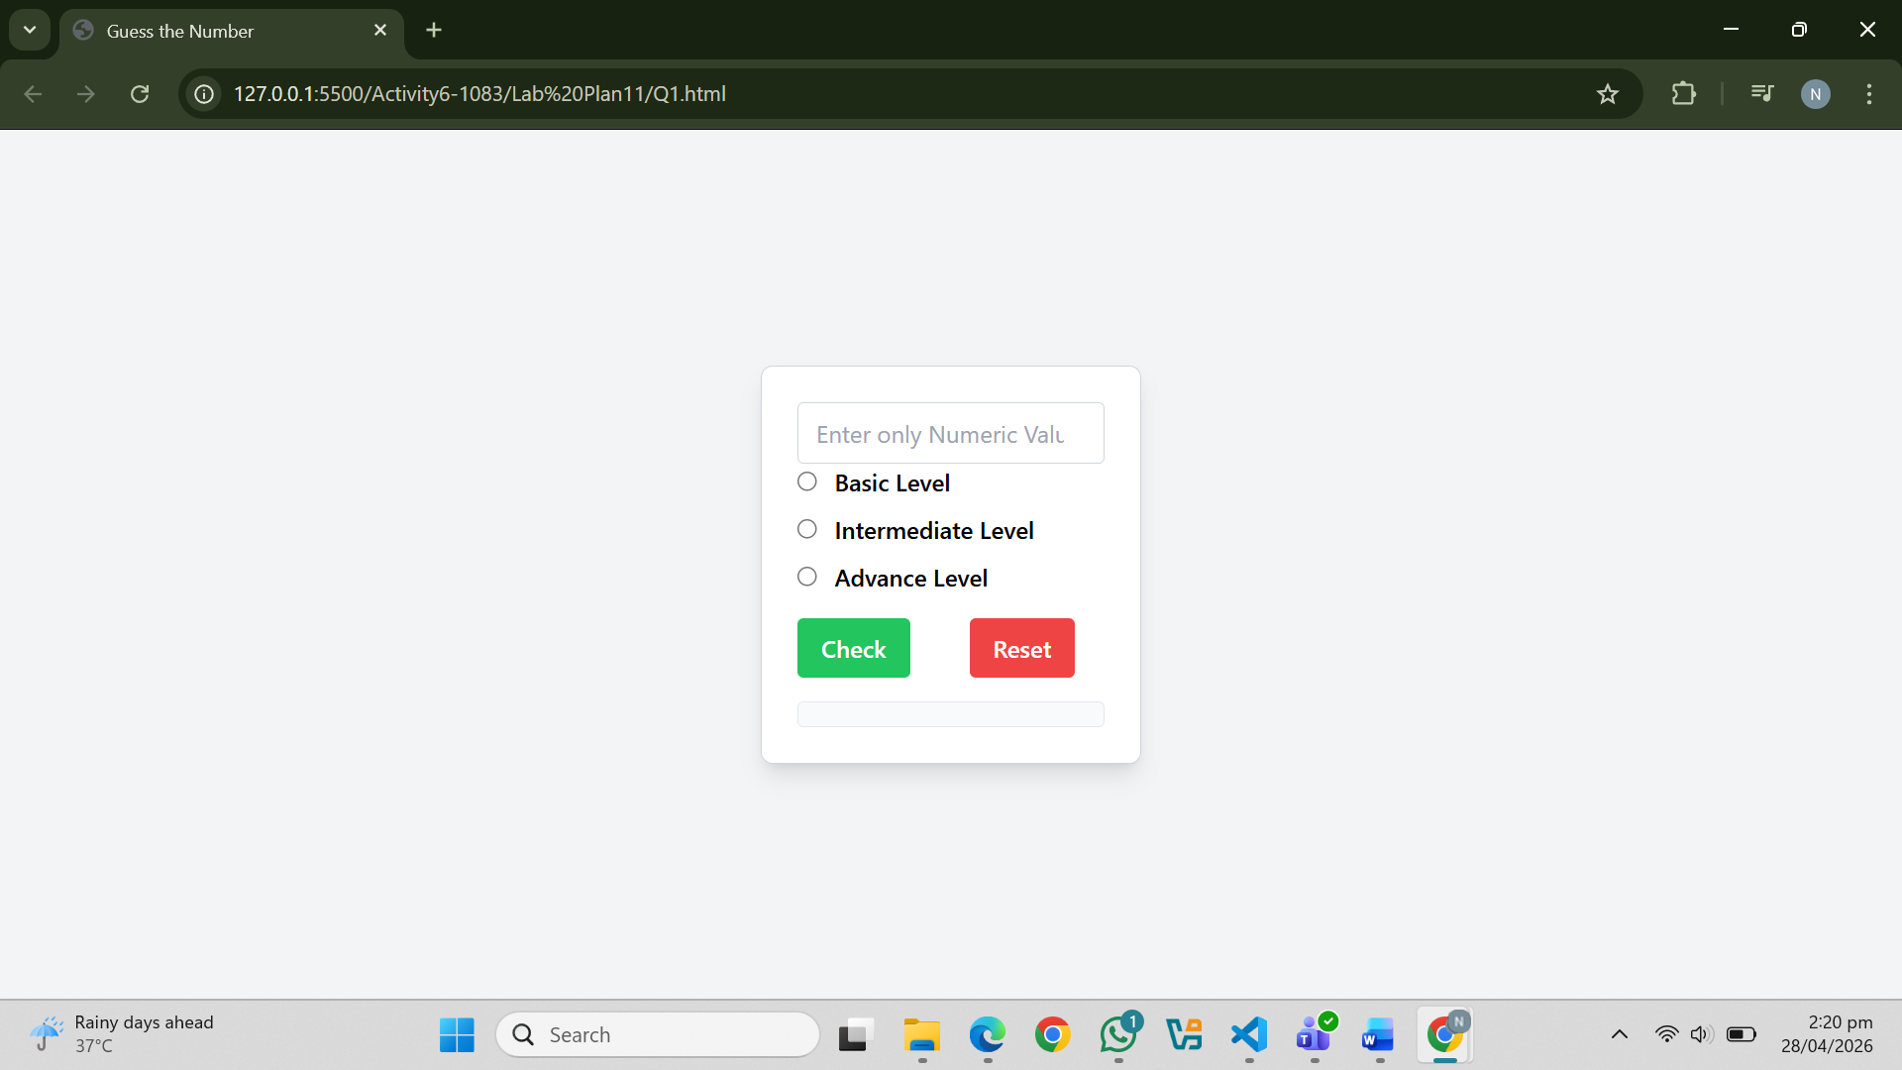
Question. No.2
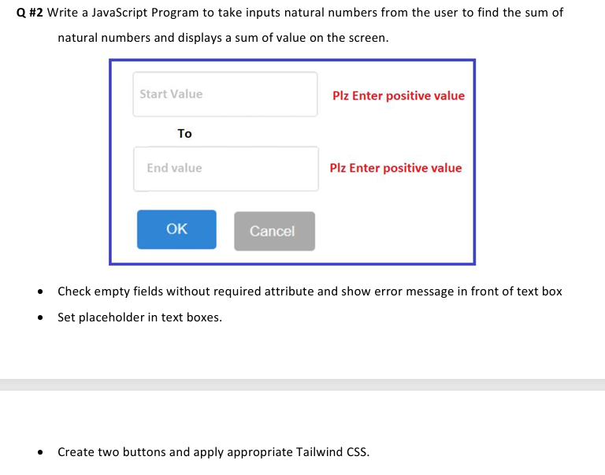
Code:
<!DOCTYPE html>
<html lang="en">
<head>
<meta charset="UTF-8" />
<meta name="viewport" content="width=device-width, initial-scale=1.0"/>
<title>Sum of Natural Numbers</title>
<script src="https://cdn.tailwindcss.com"></script>
</head>
<body class="bg-gray-100 flex items-center justify-center min-h-screen p-4">

<div class="border-4 border-blue-600 rounded-lg p-6 max-w-md w-full shadow-lg bg-white">
<div class="border border-blue-500 rounded-lg p-4 mb-4">
<!-- Start Input -->
<div class="mb-4">
<label class="block mb-1 text-gray-700 font-medium">Start Value</label>
<input
type="number"
id="start-input"
placeholder="Start Value"
class="w-full border border-gray-300 rounded px-3 py-2 focus:outline-none focus:ring-2 focus:ring-blue-400"
/>
<p id="start-error" class="text-red-600 text-sm mt-1 hidden">Plz Enter positive value</p>
</div>
<h2 class="text-2xl font-bold text-center text-black-600 mb-6">TO</h2>
<!-- End Input -->
<div class="mb-4">
<label class="block mb-1 text-gray-700 font-medium">End Value</label>
<input
type="number"
id="end-input"
placeholder="End Value"
class="w-full border border-gray-300 rounded px-3 py-2 focus:outline-none focus:ring-2 focus:ring-blue-400"
/>
<p id="end-error" class="text-red-600 text-sm mt-1 hidden">Plz Enter positive value</p>
</div>
<!-- Buttons -->
<div class="flex gap-2 justify-center mb-4">
<button
onclick="calculateSum()"
class="bg-blue-600 text-white px-4 py-2 rounded hover:bg-blue-500"
>
OK
</button>
<button
onclick="clearFields()"
class="bg-gray-400 text-white px-4 py-2 rounded hover:bg-gray-300"
>
Cancel
</button>
</div>
<!-- Result Display -->
<div
id="result"
class="hidden border border-gray-300 rounded p-4 text-center bg-gray-50"
>
<p class="text-gray-700 mb-2">Sum of numbers from start to end:</p>
<p
id="sum-result"
class="text-xl font-semibold text-blue-600 font-mono"
></p>
</div>
</div>
</div>

<script>
function calculateSum() {
const startInput = document.getElementById('start-input');
const endInput = document.getElementById('end-input');
const startErr = document.getElementById('start-error');
const endErr = document.getElementById('end-error');
const resultDiv = document.getElementById('result');
const resultText = document.getElementById('sum-result');

// Hide error messages and result initially
startErr.classList.add('hidden');
endErr.classList.add('hidden');
resultDiv.classList.add('hidden');

const startVal = startInput.value.trim();
const endVal = endInput.value.trim();

const startNum = parseInt(startVal);
const endNum = parseInt(endVal);

let valid = true;

if (startVal === '' || isNaN(startNum) || startNum < 1) {
startErr.classList.remove('hidden');
valid = false;
}
if (endVal === '' || isNaN(endNum) || endNum < 1) {
endErr.classList.remove('hidden');
valid = false;
}
if (!valid) return;

if (startNum > endNum) {
alert('Start value should be less than or equal to End value.');
return;
}

let sum = 0;
for (let i = startNum; i <= endNum; i++) {
sum += i;
}

resultText.textContent = sum;
resultDiv.classList.remove('hidden');
}

function clearFields() {
document.getElementById('start-input').value = '';
document.getElementById('end-input').value = '';
document.getElementById('start-error').classList.add('hidden');
document.getElementById('end-error').classList.add('hidden');
document.getElementById('result').classList.add('hidden');
}
</script>

</body>
</html>
Output:
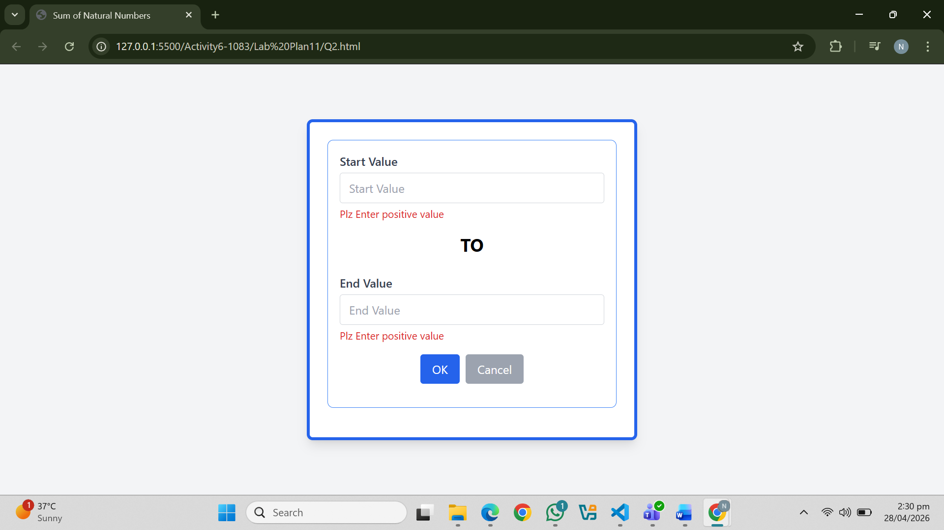
Question. No.3
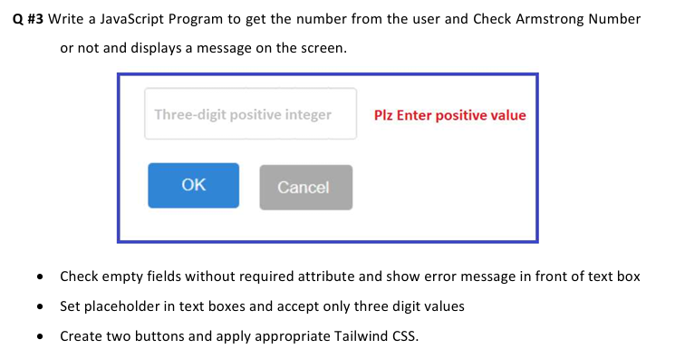
Code:
<!DOCTYPE html>
<html lang="en">
<head>
<meta charset="UTF-8"/>
<meta name="viewport" content="width=device-width, initial-scale=1.0"/>
<title>Q3 - Armstrong Number</title>
<script src="https://cdn.tailwindcss.com"></script>
</head>
<body class="bg-gray-100 flex items-center justify-center min-h-screen p-4">

<div class="border-4 border-blue-600 rounded-lg p-6 max-w-md w-full shadow-lg bg-white">
<div class="mb-2">
<input
type="number"
id="num-input"
placeholder="Three Digit Positive integer"
min="100"
max="999"
class="w-full bg-gray-100 text-white rounded-xl px-4 py-2.5 font-mono outline-none border border-gray-600 focus:border-purple-400 transition"
/>
<p id="num-err" class="text-red-400 text-sm mt-1 hidden">⚠ Please enter a valid 3-digit number (100 – 999).</p>
</div>

<div class="flex gap-3 mt-5">
<button onclick="checkArmstrong()"
class="flex-1 bg-purple-500 hover:bg-purple-400 text-white font-bold py-2.5 rounded-xl transition">
Ok
</button>
<button onclick="clearForm()"
class="flex-1 border border-gray-600 hover:border-purple-400 text-gray-400 hover:text-purple-400 font-bold py-2.5 rounded-xl transition">
Cancel
</button>
</div>

<!-- Result -->
<div id="result" class="hidden mt-5 bg-gray-900 rounded-xl p-4 border border-gray-700 space-y-2">
<p id="calc-text" class="text-gray-400 text-sm font-mono"></p>
<p id="result-text" class="text-xl font-bold"></p>
</div>
</div>

<script>
function checkArmstrong() {
const input = document.getElementById('num-input');
const errEl = document.getElementById('num-err');
const resultDiv = document.getElementById('result');

errEl.classList.add('hidden');
resultDiv.classList.add('hidden');

const val = input.value.trim();
const n = parseInt(val);

if (val === '' || isNaN(n) || n < 100 || n > 999) {
errEl.classList.remove('hidden');
return;
}

const digits = val.split('').map(Number);
const d1 = digits[0], d2 = digits[1], d3 = digits[2];
const sum = Math.pow(d1, 3) + Math.pow(d2, 3) + Math.pow(d3, 3);
const isArm = sum === n;

document.getElementById('calc-text').textContent =
`${d1}³ + ${d2}³ + ${d3}³ = ${d1**3} + ${d2**3} + ${d3**3} = ${sum}`;

const resultText = document.getElementById('result-text');
if (isArm) {
resultText.textContent = `✅ ${n} is an Armstrong Number!`;
resultText.className = 'text-xl font-bold text-green-400';
} else {
resultText.textContent = `❌ ${n} is NOT an Armstrong Number.`;
resultText.className = 'text-xl font-bold text-red-400';
}

resultDiv.classList.remove('hidden');
}

function clearForm() {
document.getElementById('num-input').value = '';
document.getElementById('num-err').classList.add('hidden');
document.getElementById('result').classList.add('hidden');
}
</script>
</body>
</html>
Output:
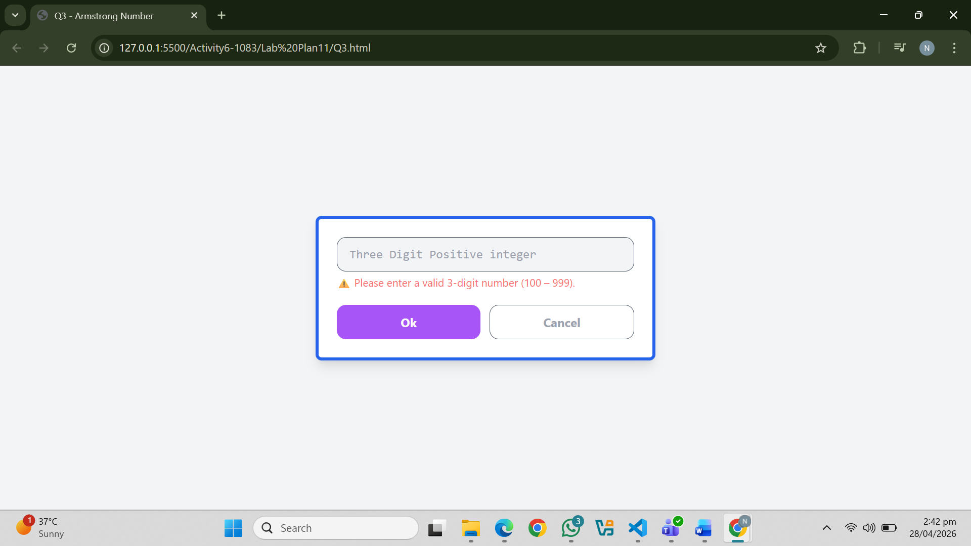
Question. No.4
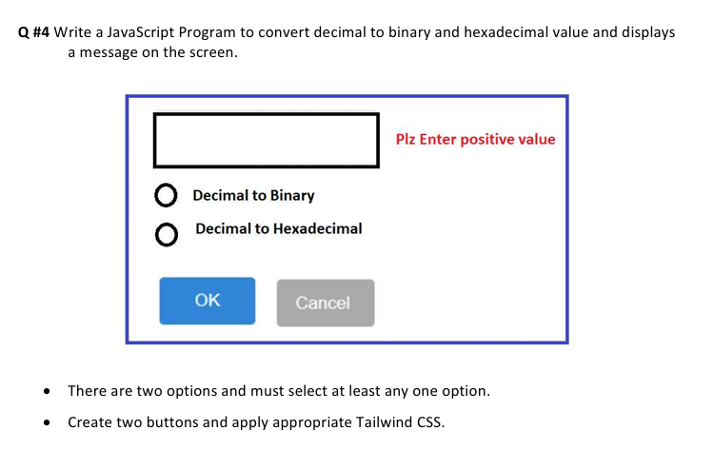
Code:
<!DOCTYPE html>
<html lang="en">
<head>
<meta charset="UTF-8"/>
<title>Q4 - Decimal Converter</title>
<script src="https://cdn.tailwindcss.com"></script>
</head>
<body class="bg-white flex items-center justify-center min-h-screen">

<div class="border-2 border-blue-600 rounded p-8 w-96">

<!-- Input Row -->
<div class="flex items-center gap-4 mb-6">
<input
type="number"
id="decInput"
placeholder=""
class="border-2 border-gray-800 w-56 h-12 px-3 text-base outline-none"
/>
<span id="inputErr" class="text-red-500 font-semibold text-sm hidden">Plz Enter positive value</span>
</div>

<!-- Radio Options -->
<div class="space-y-3 mb-8">
<label class="flex items-center gap-3 cursor-pointer">
<input type="radio" name="convType" value="binary" class="w-5 h-5 accent-black"/>
<span class="text-base font-medium">Decimal to Binary</span>
</label>
<label class="flex items-center gap-3 cursor-pointer">
<input type="radio" name="convType" value="hex" class="w-5 h-5 accent-black"/>
<span class="text-base font-medium">Decimal to Hexadecimal</span>
</label>
</div>
<p id="optErr" class="text-red-500 text-sm mb-3 hidden">⚠ Please select at least one option.</p>

<!-- Buttons -->
<div class="flex gap-4">
<button
onclick="convert()"
class="bg-blue-500 hover:bg-blue-600 text-white font-semibold px-8 py-2 rounded">
OK
</button>
<button
onclick="cancelForm()"
class="bg-gray-400 hover:bg-gray-500 text-white font-semibold px-6 py-2 rounded">
Cancel
</button>
</div>

</div>

<script>
function convert() {
const input = document.getElementById('decInput');
const inputErr = document.getElementById('inputErr');
const optErr = document.getElementById('optErr');

inputErr.classList.add('hidden');
optErr.classList.add('hidden');

const val = input.value.trim();
const n = parseInt(val);

if (val === '' || isNaN(n) || n < 0) {
inputErr.classList.remove('hidden');
return;
}

const selected = document.querySelector('input[name="convType"]:checked');
if (!selected) {
optErr.classList.remove('hidden');
return;
}

if (selected.value === 'binary') {
alert(`Decimal: ${n}\nBinary: ${n.toString(2)}`);
} else {
alert(`Decimal: ${n}\nHexadecimal: ${n.toString(16).toUpperCase()}`);
}
}

function cancelForm() {
document.getElementById('decInput').value = '';
document.querySelectorAll('input[name="convType"]').forEach(r => r.checked = false);
document.getElementById('inputErr').classList.add('hidden');
document.getElementById('optErr').classList.add('hidden');
}
</script>

</body>
</html>
Output:
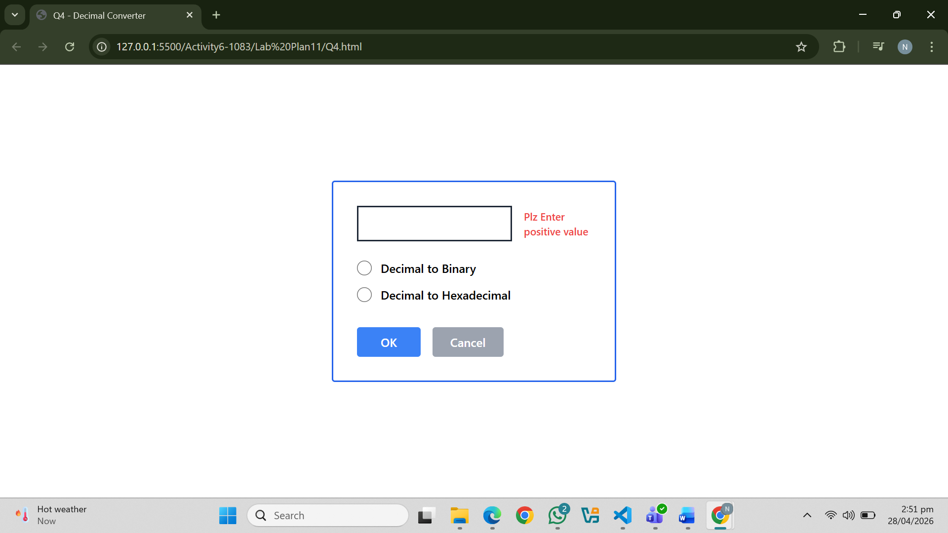
Question. No.5
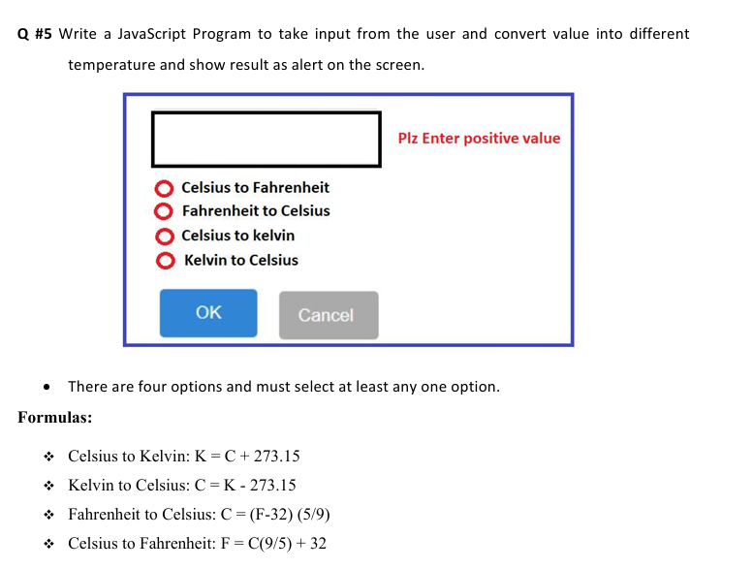
Code:
<!DOCTYPE html>
<html lang="en">
<head>
<meta charset="UTF-8"/>
<title>Q5 - Temperature Converter</title>
<script src="https://cdn.tailwindcss.com"></script>
</head>
<body class="bg-white flex items-center justify-center min-h-screen">

<div class="border-2 border-blue-600 rounded p-8 w-96">

<!-- Input Row -->
<div class="flex items-center gap-4 mb-6">
<input
type="number"
id="tempInput"
placeholder=""
class="border-2 border-gray-800 w-56 h-12 px-3 text-base outline-none"
/>
<span id="inputErr" class="text-red-500 font-semibold text-sm hidden">Plz Enter positive value</span>
</div>

<!-- Radio Options -->
<div class="space-y-3 mb-8">
<label class="flex items-center gap-3 cursor-pointer">
<input type="radio" name="tempType" value="cToF" class="w-5 h-5 accent-red-500"/>
<span class="text-base font-semibold">Celsius to Fahrenheit</span>
</label>
<label class="flex items-center gap-3 cursor-pointer">
<input type="radio" name="tempType" value="fToC" class="w-5 h-5 accent-red-500"/>
<span class="text-base font-semibold">Fahrenheit to Celsius</span>
</label>
<label class="flex items-center gap-3 cursor-pointer">
<input type="radio" name="tempType" value="cToK" class="w-5 h-5 accent-red-500"/>
<span class="text-base font-semibold">Celsius to kelvin</span>
</label>
<label class="flex items-center gap-3 cursor-pointer">
<input type="radio" name="tempType" value="kToC" class="w-5 h-5 accent-red-500"/>
<span class="text-base font-semibold">Kelvin to Celsius</span>
</label>
</div>
<p id="optErr" class="text-red-500 text-sm mb-3 hidden">⚠ Please select at least one option.</p>

<!-- Buttons -->
<div class="flex gap-4">
<button
onclick="convertTemp()"
class="bg-blue-500 hover:bg-blue-600 text-white font-semibold px-8 py-2 rounded">
OK
</button>
<button
onclick="cancelForm()"
class="bg-gray-400 hover:bg-gray-500 text-white font-semibold px-6 py-2 rounded">
Cancel
</button>
</div>

</div>

<script>
function convertTemp() {
const input = document.getElementById('tempInput');
const inputErr = document.getElementById('inputErr');
const optErr = document.getElementById('optErr');

inputErr.classList.add('hidden');
optErr.classList.add('hidden');

const val = input.value.trim();
const temp = parseFloat(val);

if (val === '' || isNaN(temp) || temp < 0) {
inputErr.classList.remove('hidden');
return;
}

const selected = document.querySelector('input[name="tempType"]:checked');
if (!selected) {
optErr.classList.remove('hidden');
return;
}

let result, message;

if (selected.value === 'cToF') {
result = (temp * (9 / 5) + 32).toFixed(2);
message = `Celsius to Fahrenheit\n\n${temp}°C = ${result}°F\n\nFormula: F = C × (9/5) + 32`;
} else if (selected.value === 'fToC') {
result = ((temp - 32) * (5 / 9)).toFixed(2);
message = `Fahrenheit to Celsius\n\n${temp}°F = ${result}°C\n\nFormula: C = (F - 32) × (5/9)`;
} else if (selected.value === 'cToK') {
result = (temp + 273.15).toFixed(2);
message = `Celsius to Kelvin\n\n${temp}°C = ${result} K\n\nFormula: K = C + 273.15`;
} else if (selected.value === 'kToC') {
result = (temp - 273.15).toFixed(2);
message = `Kelvin to Celsius\n\n${temp} K = ${result}°C\n\nFormula: C = K - 273.15`;
}

alert(message);
}

function cancelForm() {
document.getElementById('tempInput').value = '';
document.querySelectorAll('input[name="tempType"]').forEach(r => r.checked = false);
document.getElementById('inputErr').classList.add('hidden');
document.getElementById('optErr').classList.add('hidden');
}
</script>

</body>
</html>
Output:
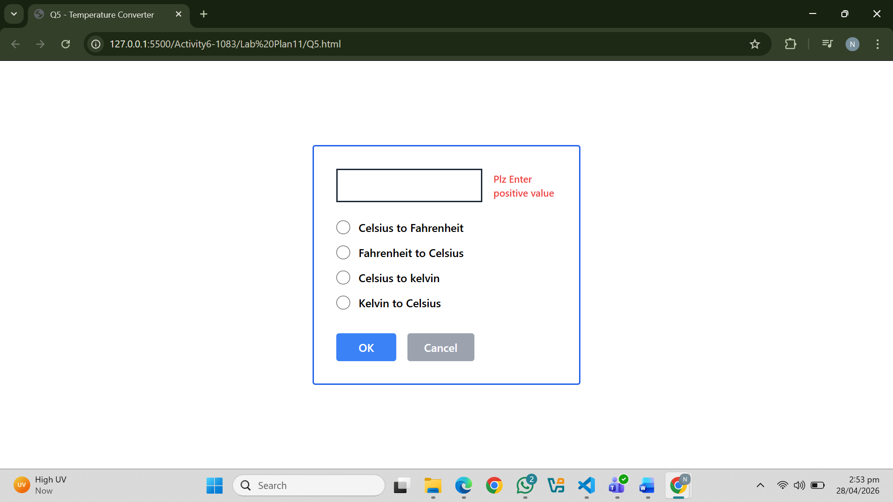
****************************************************
Lab 12:
Question. No.1
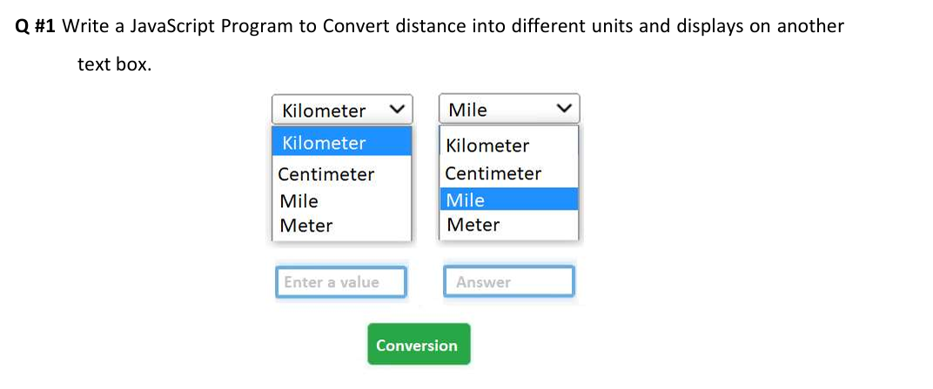
Code:
<!DOCTYPE html>
<html lang="en">
<head>
<meta charset="UTF-8"/>
<title>Q1 - Distance Converter</title>
<script src="https://cdn.tailwindcss.com"></script>
</head>
<body class="bg-white flex items-center justify-center min-h-screen">

<div class="text-center">
<!-- Two Dropdowns -->
<div class="flex gap-4 justify-center mb-4">
<select id="fromUnit" class="border border-gray-400 px-3 py-2 text-sm w-36">
<option value="km">Kilometer</option>
<option value="cm">Centimeter</option>
<option value="mile">Mile</option>
<option value="meter">Meter</option>
</select>

<select id="toUnit" class="border border-gray-400 px-3 py-2 text-sm w-36">
<option value="km">Kilometer</option>
<option value="cm">Centimeter</option>
<option value="mile">Mile</option>
<option value="meter">Meter</option>
</select>
</div>

<!-- Input and Answer -->
<div class="flex gap-4 justify-center mb-4">
<input
type="number"
id="inputVal"
placeholder="Enter a value"
class="border border-gray-300 px-3 py-1.5 text-sm w-36 outline-none focus:border-blue-400"
/>
<input
type="text"
id="answerVal"
placeholder="Answer"
readonly
class="border border-gray-300 px-3 py-1.5 text-sm w-36 bg-gray-50 text-gray-600"
/>
</div>

<p id="err" class="text-red-500 text-sm mb-2 hidden">⚠ Please enter a value.</p>

<!-- Button -->
<button
onclick="convertDistance()"
class="bg-green-600 hover:bg-green-700 text-white font-semibold px-8 py-2 rounded">
Conversion
</button>
</div>

<script>
// Conversion to meters as base unit
const toMeter = { km: 1000, cm: 0.01, mile: 1609.34, meter: 1 };

function convertDistance() {
const err = document.getElementById('err');
const val = document.getElementById('inputVal').value.trim();
err.classList.add('hidden');

if (val === '' || isNaN(val)) {
err.classList.remove('hidden');
return;
}

const from = document.getElementById('fromUnit').value;
const to = document.getElementById('toUnit').value;
const inMeters = parseFloat(val) * toMeter[from];
const result = inMeters / toMeter[to];

document.getElementById('answerVal').value = result.toFixed(4);
}
</script>

</body>
</html>
Output:
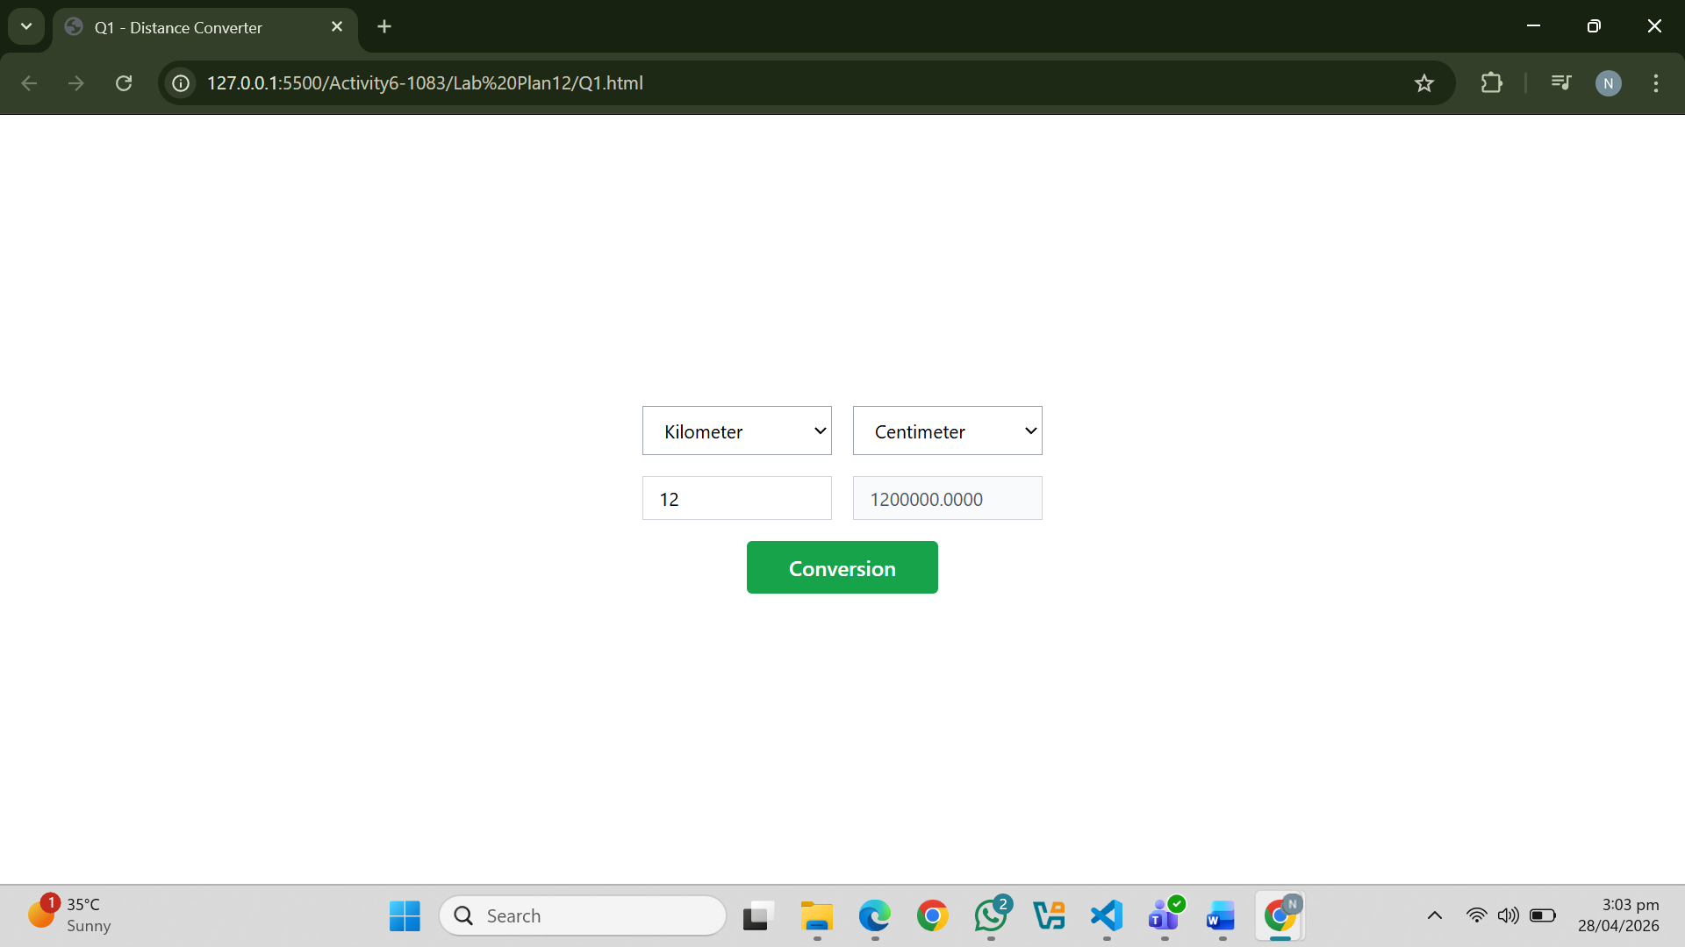
Question. No.2
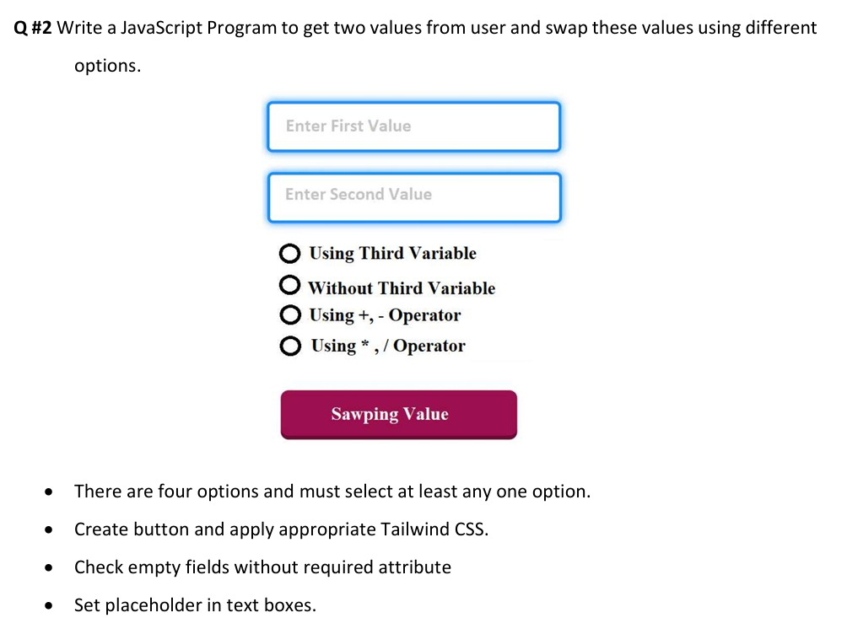
Code:
<!DOCTYPE html>
<html lang="en">
<head>
<meta charset="UTF-8"/>
<title>Q2 - Swap Values</title>
<script src="https://cdn.tailwindcss.com"></script>
</head>
<body class="bg-white flex items-center justify-center min-h-screen">

<div class="w-80">

<!-- Inputs -->
<input
type="number"
id="val1"
placeholder="Enter First Value"
class="w-full border-2 border-blue-400 px-4 py-3 mb-3 text-sm outline-none focus:border-blue-600"
/>
<p id="err1" class="text-red-500 text-xs mb-2 hidden">⚠ First field is empty or invalid (positive 3-digit only).</p>

<input
type="number"
id="val2"
placeholder="Enter Second Value"
class="w-full border-2 border-blue-400 px-4 py-3 mb-4 text-sm outline-none focus:border-blue-600"
/>
<p id="err2" class="text-red-500 text-xs mb-3 hidden">⚠ Second field is empty or invalid (positive 3-digit only).</p>

<!-- Radio Options -->
<div class="space-y-2 mb-5 pl-2">
<label class="flex items-center gap-3 cursor-pointer font-semibold text-sm">
<input type="radio" name="swapMethod" value="third" class="w-4 h-4"/> Using Third Variable
</label>
<label class="flex items-center gap-3 cursor-pointer font-semibold text-sm">
<input type="radio" name="swapMethod" value="nothird" class="w-4 h-4"/> Without Third Variable
</label>
<label class="flex items-center gap-3 cursor-pointer font-semibold text-sm">
<input type="radio" name="swapMethod" value="plus" class="w-4 h-4"/> Using +, - Operator
</label>
<label class="flex items-center gap-3 cursor-pointer font-semibold text-sm">
<input type="radio" name="swapMethod" value="mult" class="w-4 h-4"/> Using * , / Operator
</label>
</div>
<p id="optErr" class="text-red-500 text-xs mb-3 hidden">⚠ Please select a swap method.</p>

<!-- Button -->
<button
onclick="swapValues()"
class="w-full bg-rose-700 hover:bg-rose-800 text-white font-bold py-3 rounded">
Sawping Value
</button>

<!-- Result -->
<div id="result" class="hidden mt-4 bg-gray-100 border border-gray-300 rounded p-3 text-sm font-mono text-center">
</div>

</div>

<script>
function isValid(val) {
const n = parseInt(val);
return val !== '' && !isNaN(n) && n >= 100 && n <= 999;
}

function swapValues() {
const v1El = document.getElementById('val1');
const v2El = document.getElementById('val2');
const err1 = document.getElementById('err1');
const err2 = document.getElementById('err2');
const optErr = document.getElementById('optErr');
const result = document.getElementById('result');

err1.classList.add('hidden');
err2.classList.add('hidden');
optErr.classList.add('hidden');
result.classList.add('hidden');

let valid = true;
if (!isValid(v1El.value.trim())) { err1.classList.remove('hidden'); valid = false; }
if (!isValid(v2El.value.trim())) { err2.classList.remove('hidden'); valid = false; }
if (!valid) return;

const method = document.querySelector('input[name="swapMethod"]:checked');
if (!method) { optErr.classList.remove('hidden'); return; }

let a = parseInt(v1El.value);
let b = parseInt(v2El.value);
const origA = a, origB = b;

if (method.value === 'third') {
let temp = a; a = b; b = temp;
} else if (method.value === 'nothird') {
a = a + b - (b = a);
} else if (method.value === 'plus') {
a = a + b;
b = a - b;
a = a - b;
} else if (method.value === 'mult') {
a = a * b;
b = a / b;
a = a / b;
}

result.innerHTML =
`Before: A = ${origA}, B = ${origB}<br>
After Swap: A = ${a}, B = ${b}<br>
Method: ${method.value}`;
result.classList.remove('hidden');
}
</script>

</body>
</html>
Output:
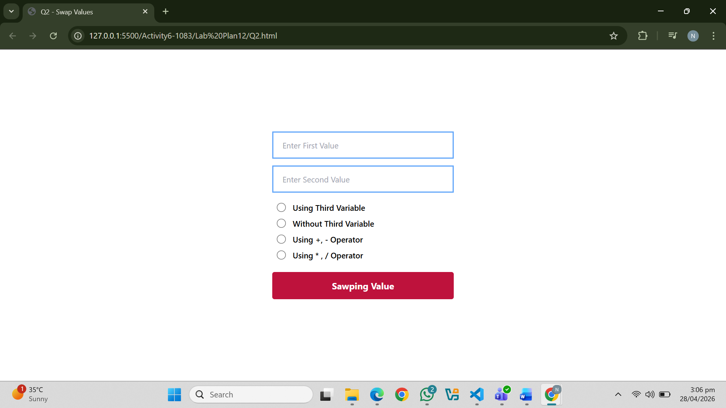
Question. No.3
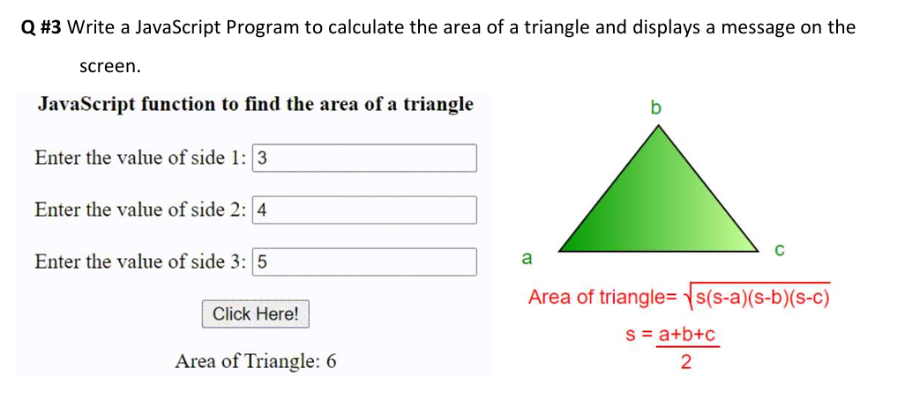
Code:
<!DOCTYPE html>
<html lang="en">
<head>
<meta charset="UTF-8"/>
<title>Q3 - Area of Triangle (Heron's)</title>
<script src="https://cdn.tailwindcss.com"></script>
</head>
<body class="bg-white flex items-center justify-center min-h-screen p-6">

<div class="flex gap-12 items-start">

<!-- Left: Form -->
<div>
<h2 class="font-bold text-base mb-4">JavaScript function to find the area of a triangle</h2>

<div class="space-y-3 mb-4">
<div class="flex items-center gap-2">
<label class="text-sm w-44">Enter the value of side 1:</label>
<input type="number" id="s1" class="border border-gray-400 px-2 py-1 w-36 text-sm outline-none"/>
</div>
<p id="err1" class="text-red-500 text-xs ml-44 hidden">⚠ Enter side 1.</p>

<div class="flex items-center gap-2">
<label class="text-sm w-44">Enter the value of side 2:</label>
<input type="number" id="s2" class="border border-gray-400 px-2 py-1 w-36 text-sm outline-none"/>
</div>
<p id="err2" class="text-red-500 text-xs ml-44 hidden">⚠ Enter side 2.</p>

<div class="flex items-center gap-2">
<label class="text-sm w-44">Enter the value of side 3:</label>
<input type="number" id="s3" class="border border-gray-400 px-2 py-1 w-36 text-sm outline-none"/>
</div>
<p id="err3" class="text-red-500 text-xs ml-44 hidden">⚠ Enter side 3.</p>
</div>

<button
onclick="calcArea()"
class="border border-gray-500 bg-gray-100 hover:bg-gray-200 px-5 py-1.5 text-sm rounded mb-3">
Click Here!
</button>

<p id="result" class="text-sm font-medium"></p>
</div>

<!-- Right: Triangle image + formula -->
<div class="text-center">
<!-- SVG Triangle -->
<svg width="160" height="130" viewBox="0 0 160 130">
<polygon points="80,5 10,125 150,125" fill="#4ade80" stroke="#16a34a" stroke-width="2"/>
<text x="78" y="2" font-size="12" text-anchor="middle" fill="black">b</text>
<text x="5" y="130" font-size="12" fill="black">a</text>
<text x="148" y="130" font-size="12" fill="black">c</text>
</svg>
<p class="text-red-500 text-sm mt-2">Area of triangle= √s(s-a)(s-b)(s-c)</p>
<p class="text-sm mt-1">s = (a+b+c) / 2</p>
</div>

</div>

<script>
function calcArea() {
['err1','err2','err3'].forEach(e => document.getElementById(e).classList.add('hidden'));

const s1 = document.getElementById('s1').value.trim();
const s2 = document.getElementById('s2').value.trim();
const s3 = document.getElementById('s3').value.trim();

let valid = true;
if (s1 === '' || isNaN(s1)) { document.getElementById('err1').classList.remove('hidden'); valid = false; }
if (s2 === '' || isNaN(s2)) { document.getElementById('err2').classList.remove('hidden'); valid = false; }
if (s3 === '' || isNaN(s3)) { document.getElementById('err3').classList.remove('hidden'); valid = false; }
if (!valid) return;

const a = parseFloat(s1), b = parseFloat(s2), c = parseFloat(s3);
const s = (a + b + c) / 2;
const area = Math.sqrt(s * (s-a) * (s-b) * (s-c));

const res = document.getElementById('result');
if (isNaN(area) || area <= 0) {
res.textContent = 'Invalid triangle sides.';
res.className = 'text-sm font-medium text-red-500';
} else {
res.textContent = `Area of Triangle: ${area.toFixed(2)}`;
res.className = 'text-sm font-medium text-gray-800';
}
}
</script>

</body>
</html>
Output:
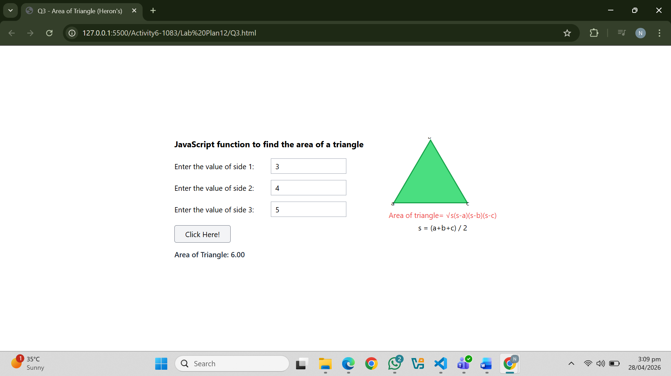
Question. No.4
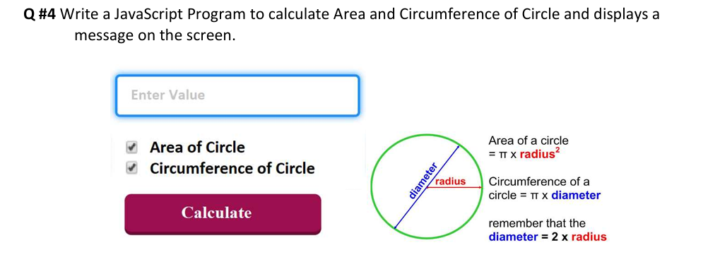
Code:
<!DOCTYPE html>
<html lang="en">
<head>
<meta charset="UTF-8"/>
<title>Q4 - Circle Calculator</title>
<script src="https://cdn.tailwindcss.com"></script>
</head>
<body class="bg-white flex items-center justify-center min-h-screen p-6">

<div class="flex gap-12 items-start">

<!-- Left: Form -->
<div class="w-64">
<input
type="number"
id="radius"
placeholder="Enter Value"
class="w-full border-2 border-blue-400 px-4 py-3 mb-4 text-sm outline-none focus:border-blue-600"
/>
<p id="inputErr" class="text-red-500 text-xs mb-3 hidden">⚠ Please enter a radius value.</p>

<div class="space-y-2 mb-5">
<label class="flex items-center gap-2 cursor-pointer text-sm font-semibold">
<input type="checkbox" id="chkArea" checked class="accent-rose-700 w-4 h-4"/> Area of Circle
</label>
<label class="flex items-center gap-2 cursor-pointer text-sm font-semibold">
<input type="checkbox" id="chkCirc" checked class="accent-rose-700 w-4 h-4"/> Circumference of Circle
</label>
</div>
<p id="optErr" class="text-red-500 text-xs mb-3 hidden">⚠ Select at least one option.</p>

<button
onclick="calculate()"
class="w-full bg-rose-700 hover:bg-rose-800 text-white font-bold py-3 rounded mb-4">
Calculate
</button>

<div id="result" class="hidden bg-gray-100 border border-gray-300 rounded p-3 text-sm space-y-1"></div>
</div>

<!-- Right: Circle diagram + formulas -->
<div class="text-sm space-y-2 pt-4">
<!-- SVG Circle -->
<svg width="160" height="160" viewBox="0 0 160 160" class="mx-auto block mb-2">
<circle cx="80" cy="80" r="68" fill="none" stroke="#22c55e" stroke-width="3"/>
<!-- diameter line (diagonal blue) -->
<line x1="28" y1="28" x2="132" y2="132" stroke="blue" stroke-width="1.5"/>
<!-- radius line (red) -->
<line x1="80" y1="80" x2="132" y2="80" stroke="red" stroke-width="1.5"/>
<text x="60" y="100" font-size="10" fill="blue">diameter</text>
<text x="95" y="75" font-size="10" fill="red">radius</text>
</svg>
<p><span class="text-black">Area of a circle</span><br/>= π × <span class="text-red-500 font-bold">radius²</span></p>
<p><span class="text-black">Circumference of a circle</span><br/>= π × <span class="text-blue-600 font-bold">diameter</span></p>
<p>remember that the<br/><span class="text-blue-600 font-bold">diameter = 2 × radius</span></p>
</div>

</div>

<script>
function calculate() {
const inputErr = document.getElementById('inputErr');
const optErr = document.getElementById('optErr');
const result = document.getElementById('result');

inputErr.classList.add('hidden');
optErr.classList.add('hidden');
result.classList.add('hidden');

const val = document.getElementById('radius').value.trim();
if (val === '' || isNaN(val) || parseFloat(val) <= 0) {
inputErr.classList.remove('hidden');
return;
}

const chkArea = document.getElementById('chkArea').checked;
const chkCirc = document.getElementById('chkCirc').checked;
if (!chkArea && !chkCirc) { optErr.classList.remove('hidden'); return; }

const r = parseFloat(val);
let html = `<p class="font-semibold">Radius = ${r}</p>`;

if (chkArea) {
const area = (Math.PI * r * r).toFixed(4);
html += `<p>Area = π × r² = <strong>${area}</strong></p>`;
}
if (chkCirc) {
const circ = (Math.PI * 2 * r).toFixed(4);
html += `<p>Circumference = π × 2r = <strong>${circ}</strong></p>`;
}

result.innerHTML = html;
result.classList.remove('hidden');
}
</script>

</body>
</html>
Output:
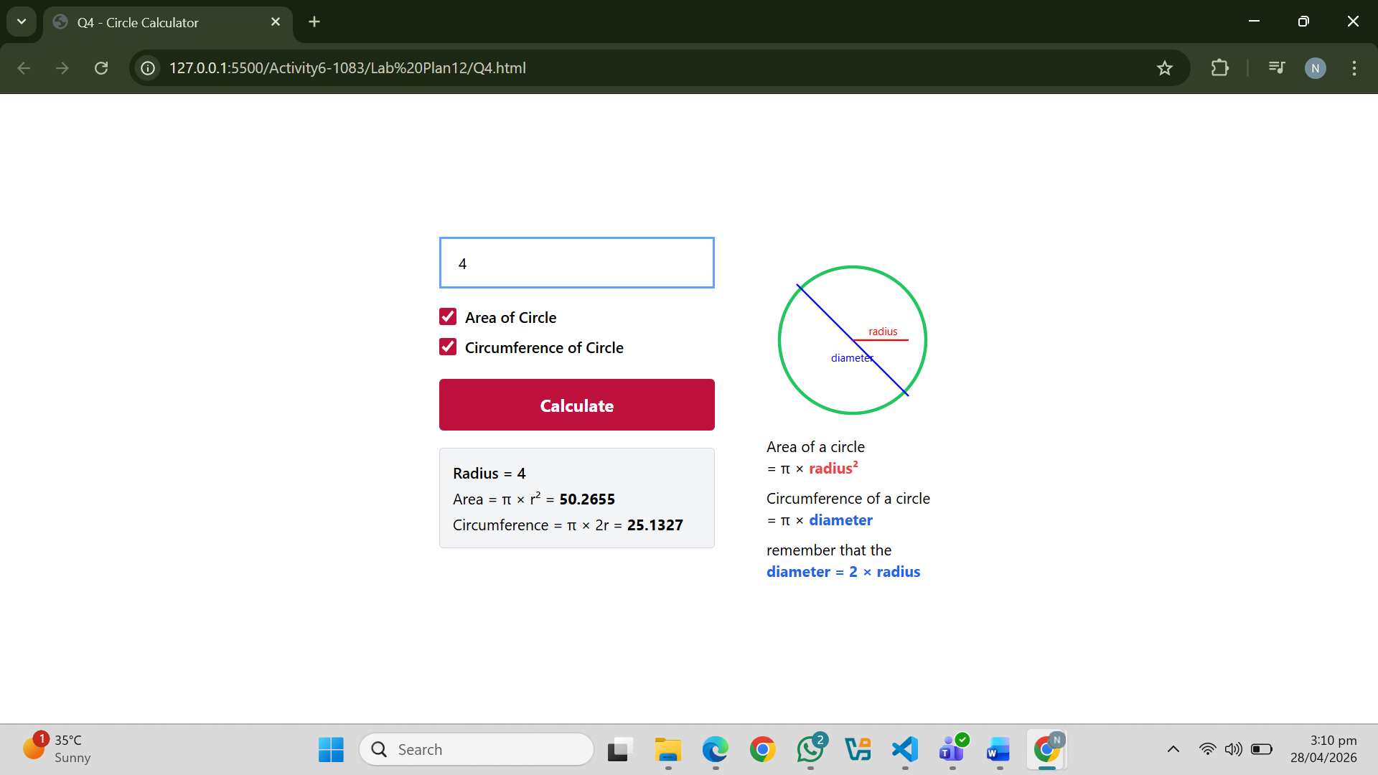
Question. No.5
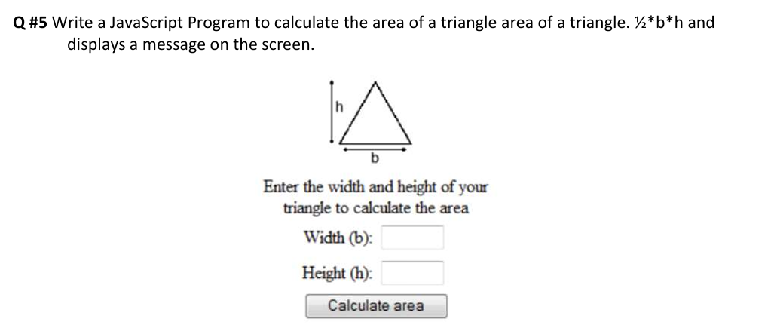
Code:
<!DOCTYPE html>
<html lang="en">
<head>
<meta charset="UTF-8"/>
<title>Q5 - Triangle Area (½bh)</title>
<script src="https://cdn.tailwindcss.com"></script>
</head>
<body class="bg-white flex items-center justify-center min-h-screen">

<div class="text-center w-72">

<!-- Triangle SVG -->
<svg width="120" height="100" viewBox="0 0 120 100" class="mx-auto mb-2">
<polygon points="60,5 10,95 110,95" fill="none" stroke="black" stroke-width="2"/>
<!-- height line -->
<line x1="60" y1="5" x2="60" y2="95" stroke="black" stroke-width="1" stroke-dasharray="4"/>
<text x="63" y="50" font-size="11" fill="black">h</text>
<text x="55" y="108" font-size="11" fill="black">b</text>
</svg>

<p class="text-sm font-bold mb-4">
Enter the width and height of your triangle to calculate the area
</p>

<!-- Width -->
<div class="flex items-center justify-center gap-3 mb-2">
<label class="text-sm font-semibold w-24 text-right">Width (b):</label>
<input type="number" id="base"
class="border border-gray-400 px-2 py-1 w-28 text-sm outline-none"/>
</div>
<p id="bErr" class="text-red-500 text-xs mb-2 hidden">⚠ Enter width (b).</p>

<!-- Height -->
<div class="flex items-center justify-center gap-3 mb-2">
<label class="text-sm font-semibold w-24 text-right">Height (h):</label>
<input type="number" id="height"
class="border border-gray-400 px-2 py-1 w-28 text-sm outline-none"/>
</div>
<p id="hErr" class="text-red-500 text-xs mb-3 hidden">⚠ Enter height (h).</p>

<!-- Button -->
<button
onclick="calcArea()"
class="border border-gray-500 bg-gray-100 hover:bg-gray-200 px-5 py-1.5 text-sm rounded">
Calculate area
</button>

<p id="result" class="mt-4 text-sm font-semibold"></p>
</div>

<script>
function calcArea() {
document.getElementById('bErr').classList.add('hidden');
document.getElementById('hErr').classList.add('hidden');

const b = document.getElementById('base').value.trim();
const h = document.getElementById('height').value.trim();

let valid = true;
if (b === '' || isNaN(b) || parseFloat(b) <= 0) {
document.getElementById('bErr').classList.remove('hidden'); valid = false;
}
if (h === '' || isNaN(h) || parseFloat(h) <= 0) {
document.getElementById('hErr').classList.remove('hidden'); valid = false;
}
if (!valid) return;

const area = 0.5 * parseFloat(b) * parseFloat(h);
document.getElementById('result').textContent = `Area of Triangle = ${area.toFixed(2)}`;
}
</script>

</body>
</html>
Output:
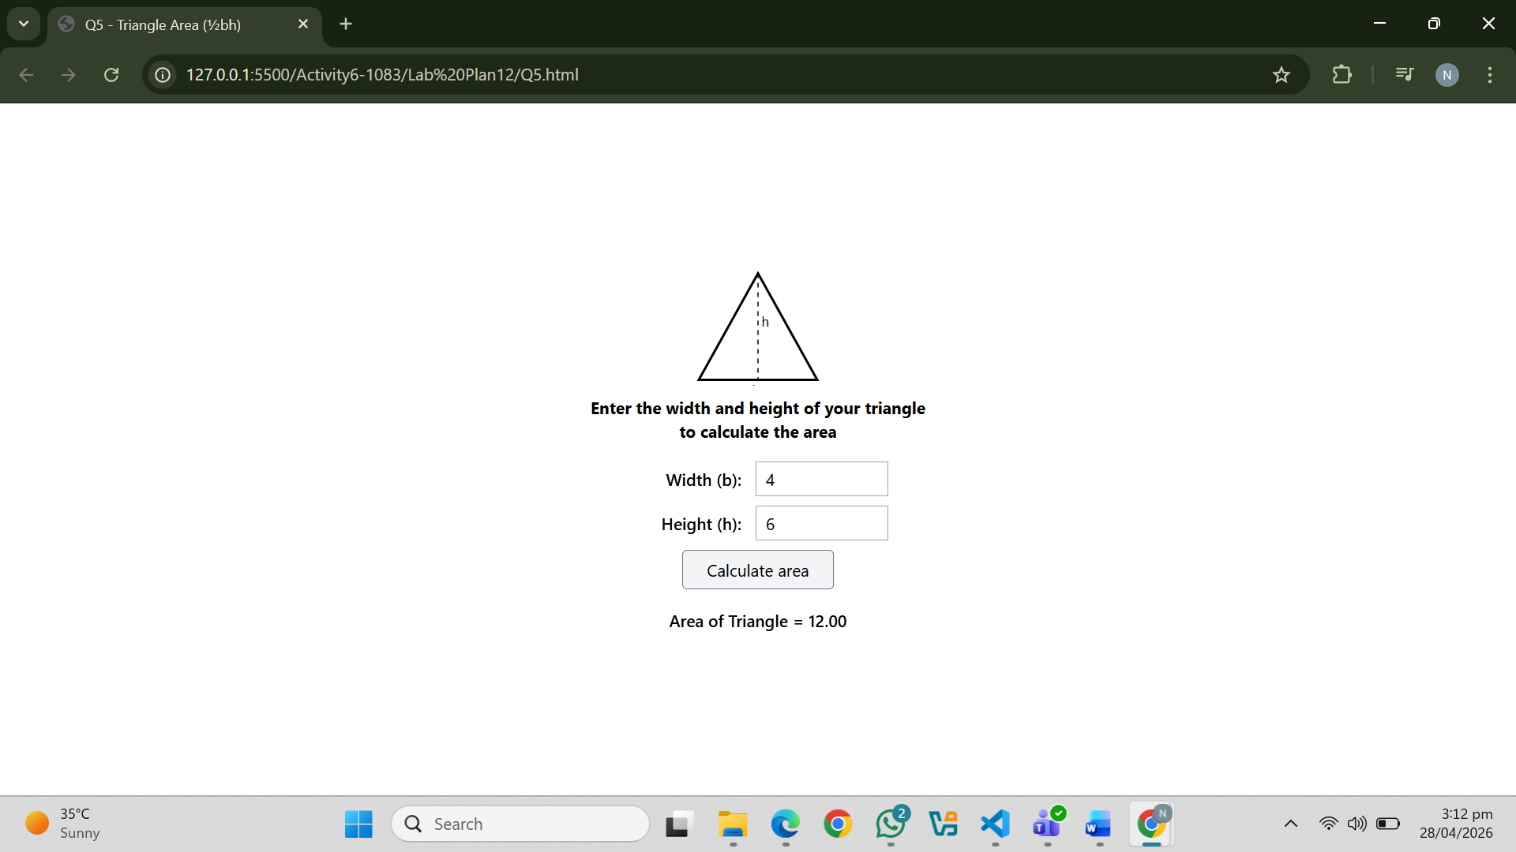
Question.NO.6
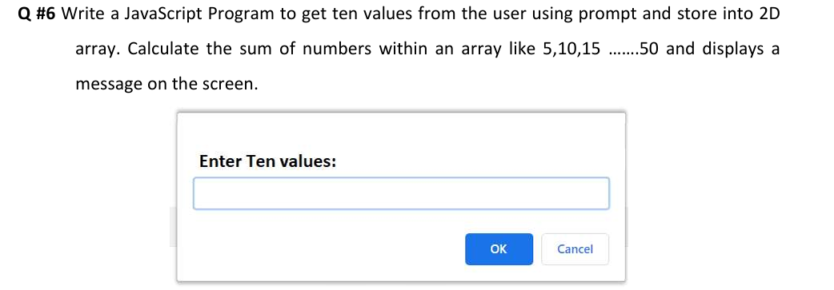
Code:
<!DOCTYPE html>
<html lang="en">
<head>
<meta charset="UTF-8"/>
<title>Q6 - 2D Array Sum</title>
<script src="https://cdn.tailwindcss.com"></script>
</head>
<body class="bg-gray-100 flex items-center justify-center min-h-screen">

<div class="bg-white rounded-lg shadow-lg p-8 w-96">
<h2 class="font-bold text-base mb-4">Enter Ten values:</h2>

<input
type="text"
id="display"
readonly
placeholder=""
class="w-full border border-blue-400 px-3 py-2 text-sm mb-5 outline-none bg-white"
/>

<div class="flex justify-end gap-3">
<button
onclick="collectValues()"
class="bg-blue-500 hover:bg-blue-600 text-white font-semibold px-6 py-1.5 rounded text-sm">
OK
</button>
<button
onclick="cancelAll()"
class="text-blue-500 hover:underline text-sm px-2">
Cancel
</button>
</div>

<!-- Result display -->
<div id="result" class="hidden mt-5 bg-gray-50 border border-gray-200 rounded p-3 text-sm font-mono"></div>
</div>

<script>
// 2D array: 2 rows x 5 columns
function collectValues() {
const values = [];

for (let i = 0; i < 10; i++) {
const input = prompt(`Enter value ${i + 1} of 10:`);
if (input === null) {
alert('Cancelled.');
return;
}
const num = parseFloat(input);
if (isNaN(num)) {
alert(`Invalid input at position ${i + 1}. Please enter a number.`);
return;
}
values.push(num);
}

// Store into 2D array (2 rows × 5 cols)
const arr2D = [
[values[0], values[1], values[2], values[3], values[4]],
[values[5], values[6], values[7], values[8], values[9]]
];

// Display values in input box
document.getElementById('display').value = values.join(', ');

// Calculate sum
let sum = 0;
arr2D.forEach(row => row.forEach(v => sum += v));

// Display result
const res = document.getElementById('result');
res.innerHTML =
`<p><b>2D Array:</b></p>
<p>Row 1: [${arr2D[0].join(', ')}]</p>
<p>Row 2: [${arr2D[1].join(', ')}]</p>
<p class="mt-2 text-green-700 font-bold">Total Sum = ${sum}</p>
<p class="text-gray-500 text-xs mt-1">Series: ${values.map((v,i)=>(i+1)*5).join(', ')} pattern check: Sum = ${sum}</p>`;
res.classList.remove('hidden');
}

function cancelAll() {
document.getElementById('display').value = '';
document.getElementById('result').classList.add('hidden');
}
</script>

</body>
</html>
Output:
